Description

Using the function Map, count the number of words that start with ‘S’ in input_list.

Sample Input:

['Santa Cruz','Santa fe','Mumbai','Delhi']

Sample Output:

2

**Approach 1:**

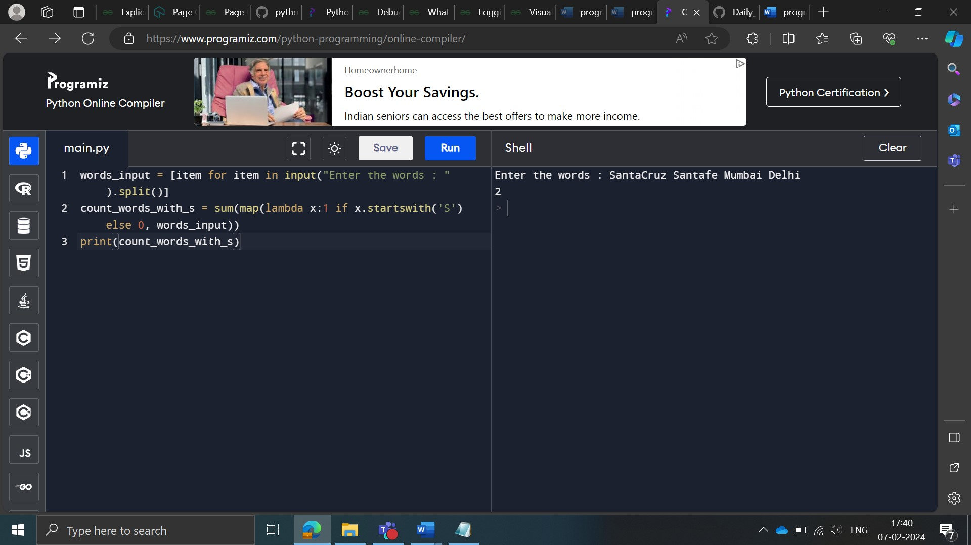

**Approach 2:**

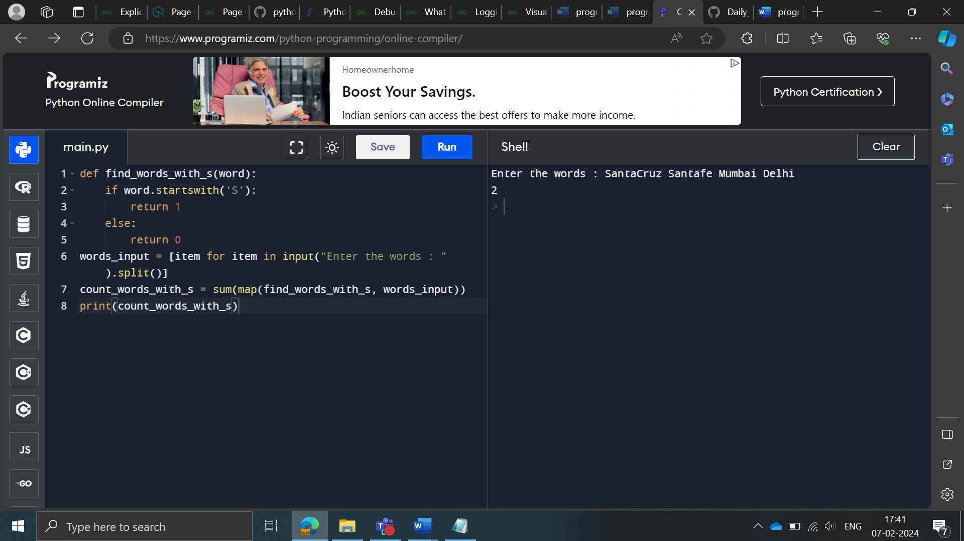

Description

Create a list ‘name’ consisting of the combination of the first name and the second name from list 1 and 2 respectively.   
  
For e.g. if the input list is:

[ ['Ankur', 'Avik', 'Kiran', 'Nitin'], ['Narang', 'Sarkar', 'R', 'Sareen']]

the output list should be the list:

['Ankur Narang', 'Avik Sarkar', 'Kiran R', 'Nitin Sareen']

Note: Add a space between first name and last name.

**Approach 1:**

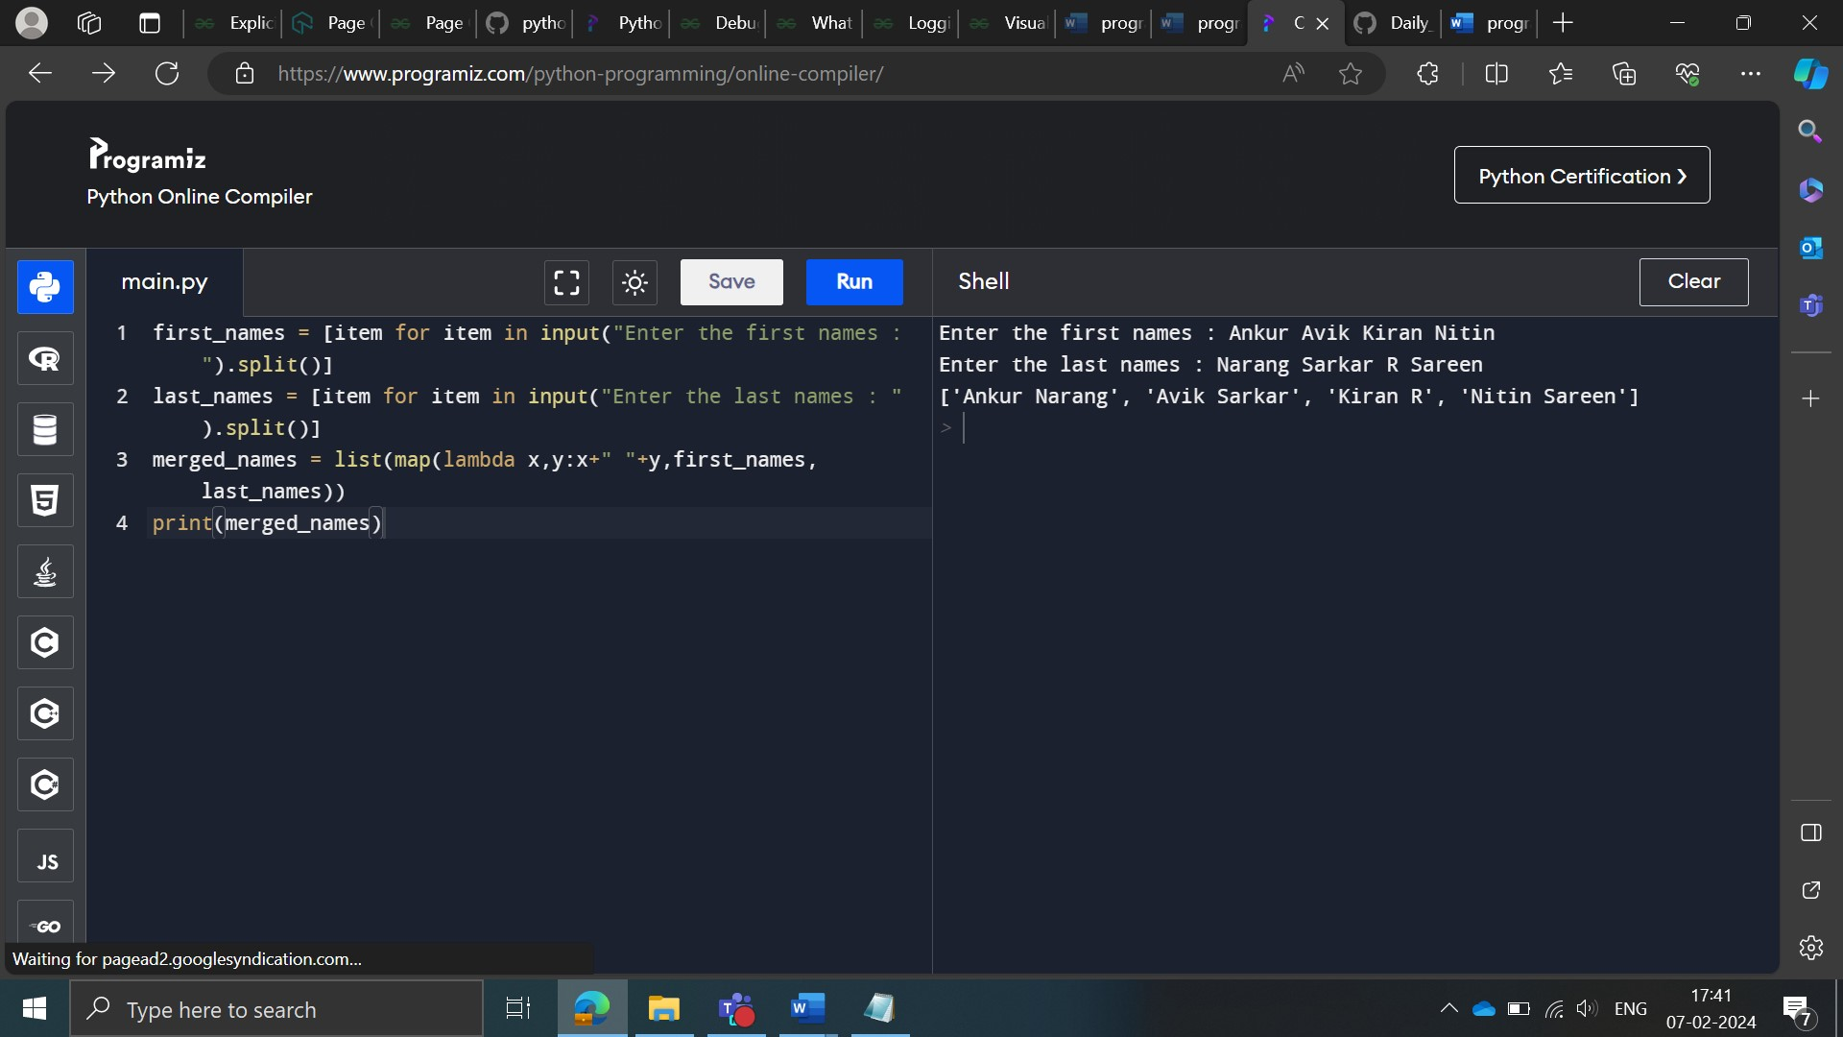

**Approach 1:**

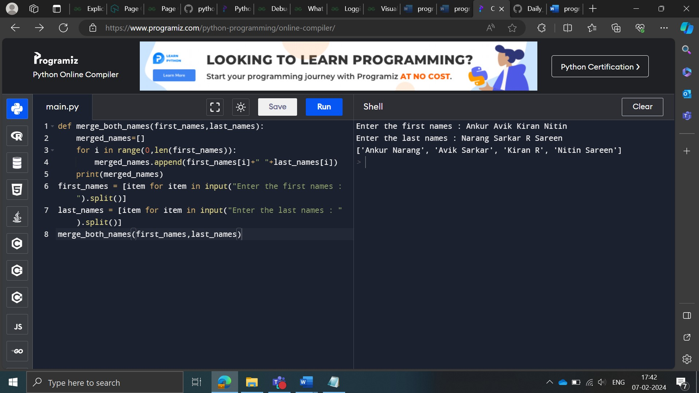

Description

Extract a list of numbers that are multiples of 5 from a list of integers named input_list.

Sample Input:

[1, 2, 3, 4, 5, 6, 7, 8, 9, 10, 11, 12, 13, 14, 15, 16, 17, 18, 19, 20, 21, 22, 23, 24, 25, 26, 27, 28, 29, 30, 31, 32, 33, 34, 35, 36, 37, 38, 39, 40, 41, 42, 43, 44, 45, 46, 47, 48, 49, 50]

Sample Output:

[5, 10, 15, 20, 25, 30, 35, 40, 45, 50]

**Approach 1:**

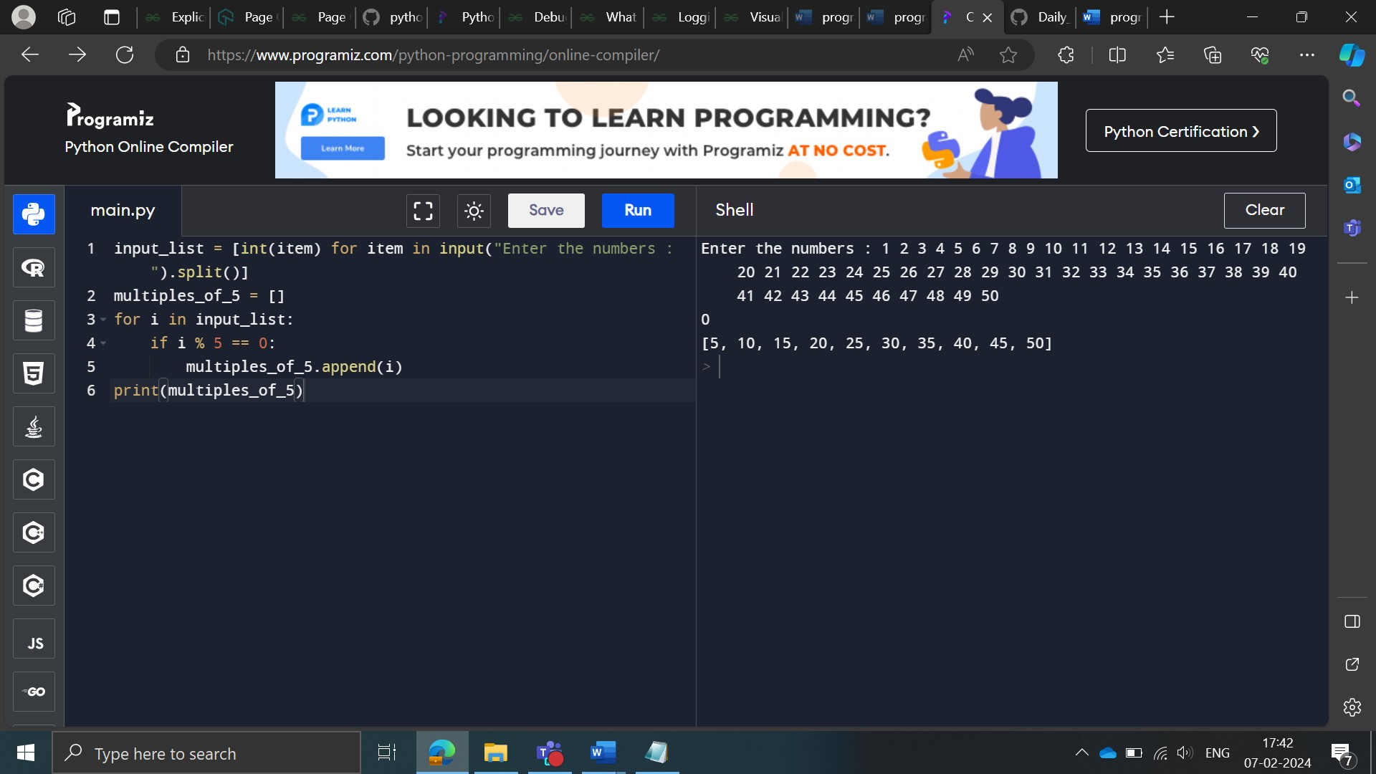

**Approach 2:**

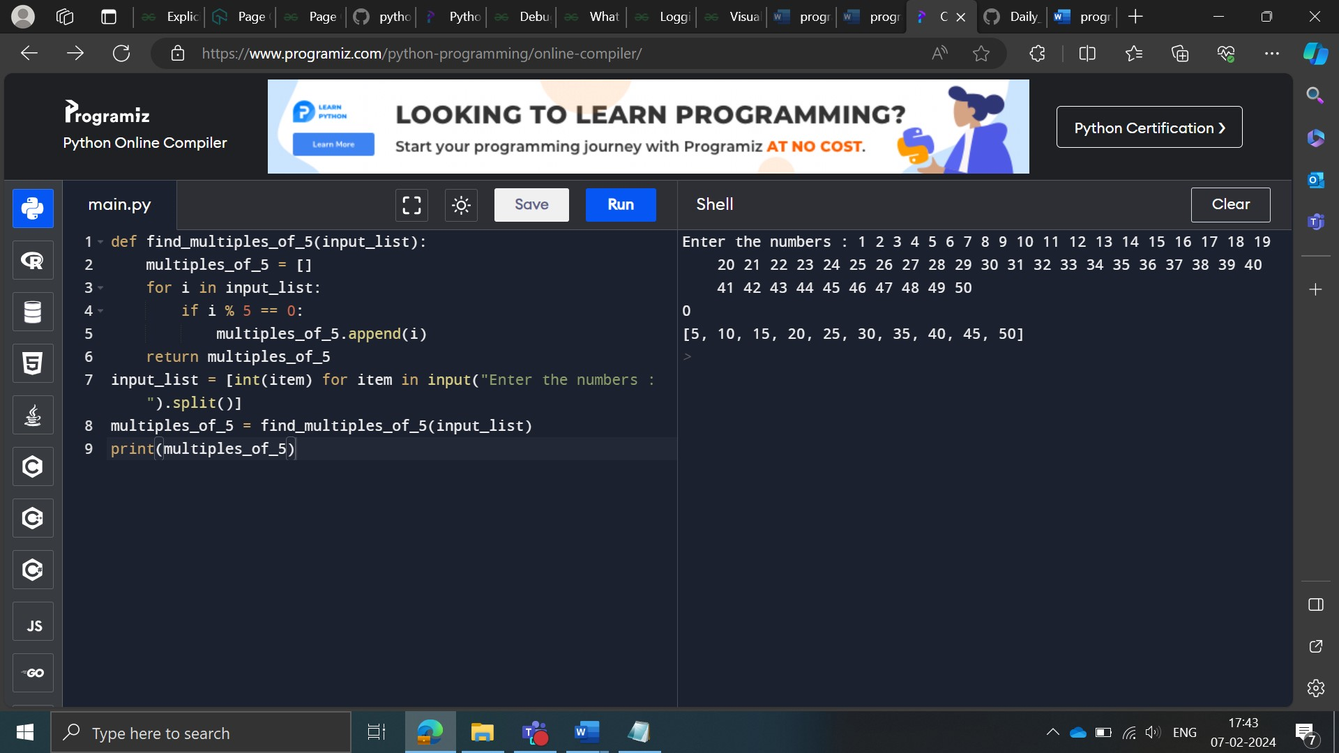

**Approach 3:**

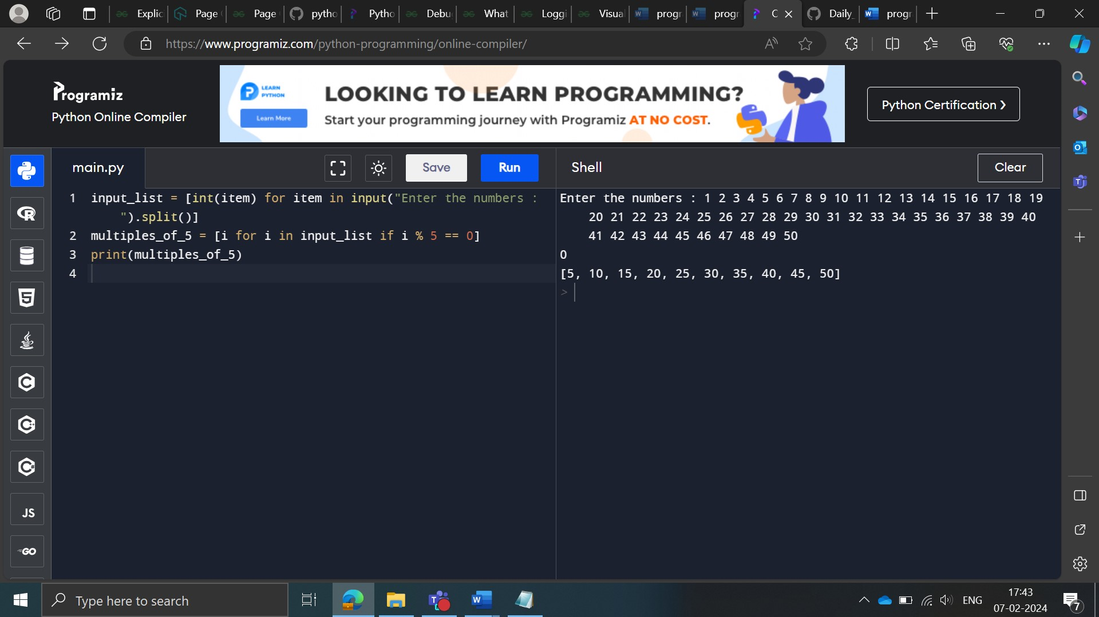

Description

You are given a list of strings such as input_list = ['hdjk', 'salsap', 'sherpa'].

Extract a list of names that start with an ‘s’ and end with a ‘p’ (both 's' and 'p' are lowercase) in input_list.

Sample Input:

['soap','sharp','shy','silent','ship','summer','sheep']

Sample Output:

['soap', 'sharp', 'ship', 'sheep']

**Approach 1:**

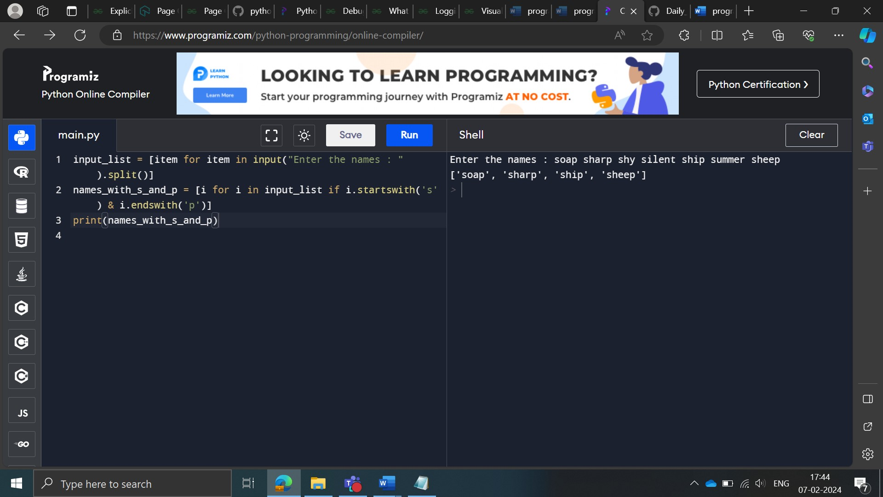

**Approach 2:**

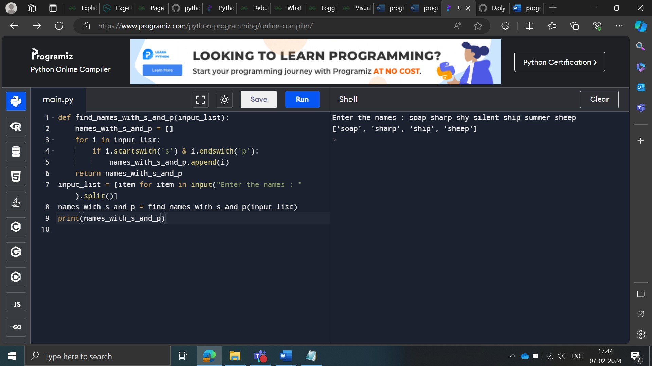

Description

Concatenate a list of words in input_list, and print the output as a string.

If input_list = ['I','Love','Python'], the output should be the string 'I Love Python'.

Sample Input:

['All','you','have','to','fear','is','fear','itself']

Sample Output:

﻿All you have to fear is fear itself

**Approach 1:**

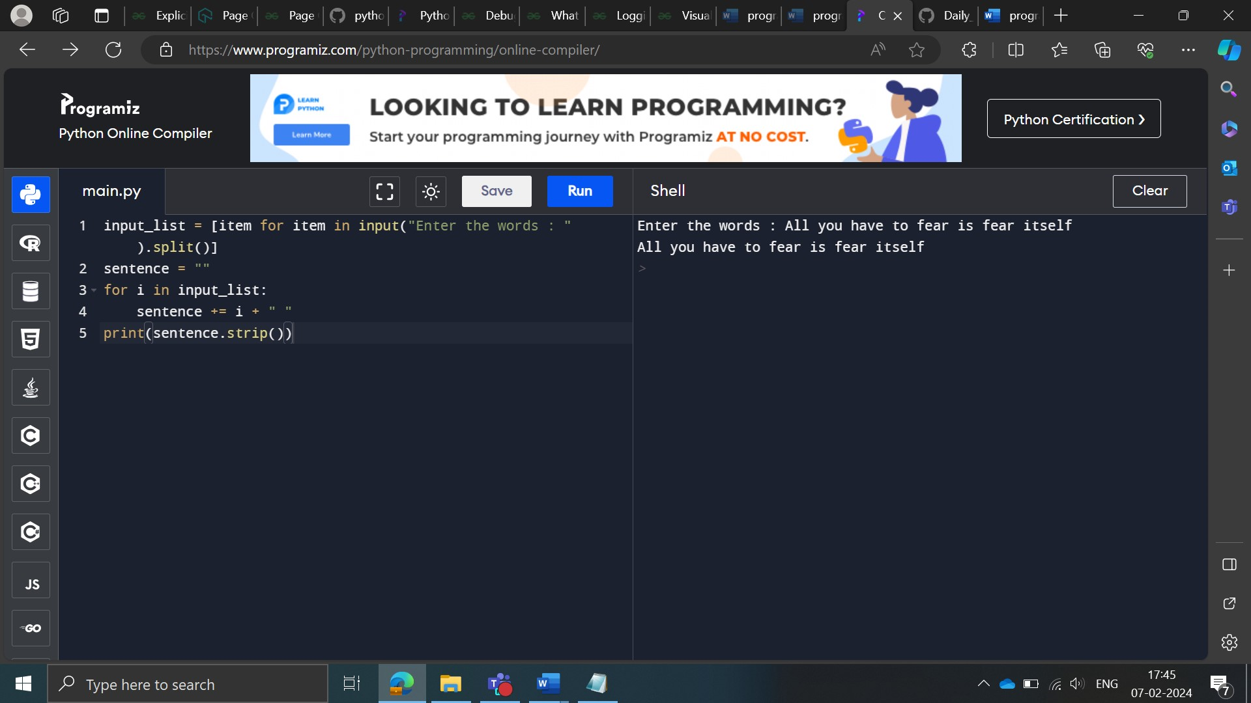

**Approach 2:**

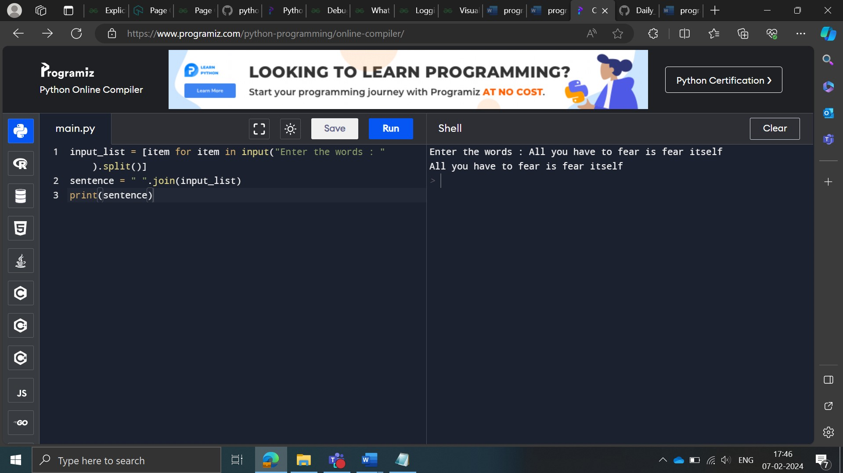

**Approach 3:**

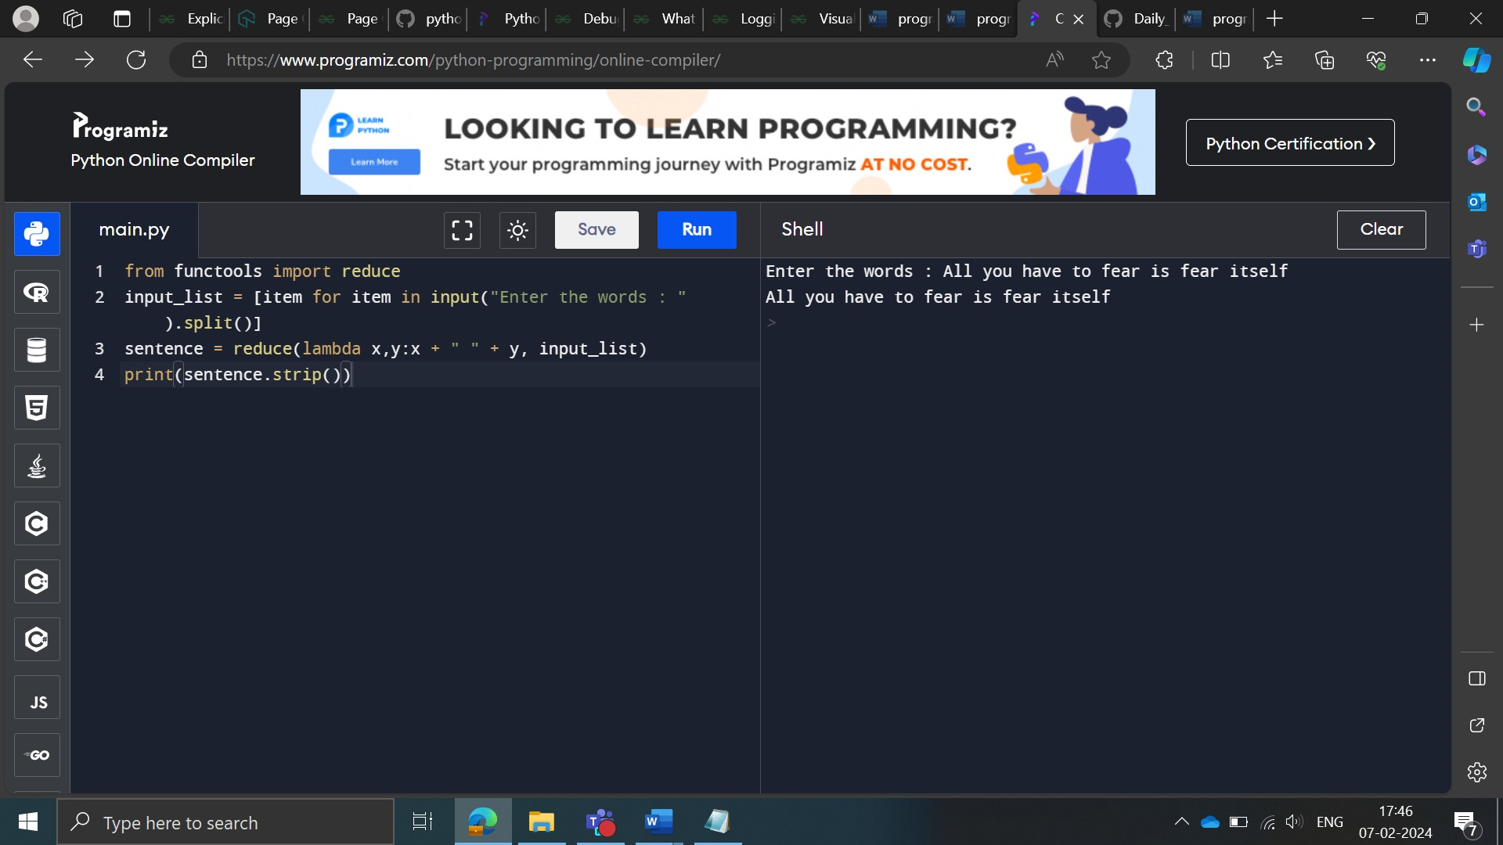

Description

Create a function squared(), which takes x and y as arguments and returns the x**y value. For e.g., if x = 2 and y = 3, then the output is 8.

Sample Input:

['6','7']

Sample Output:

﻿279936

**Approach 1:**

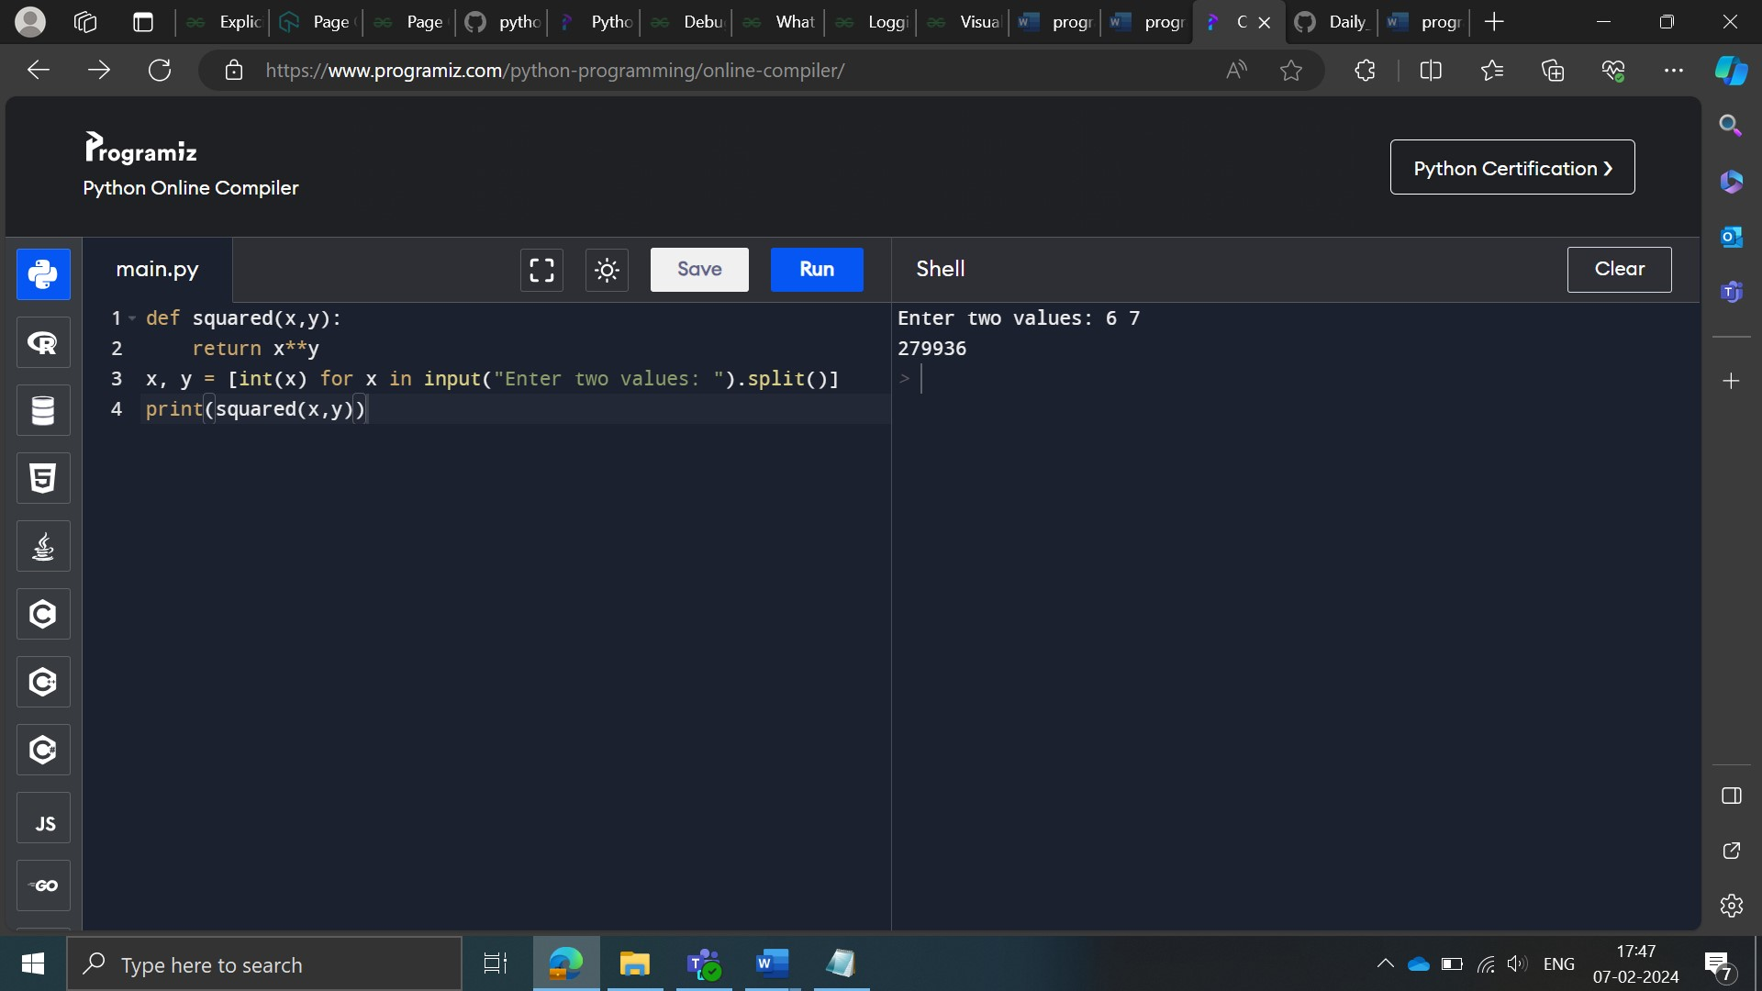

**Approach 2:**

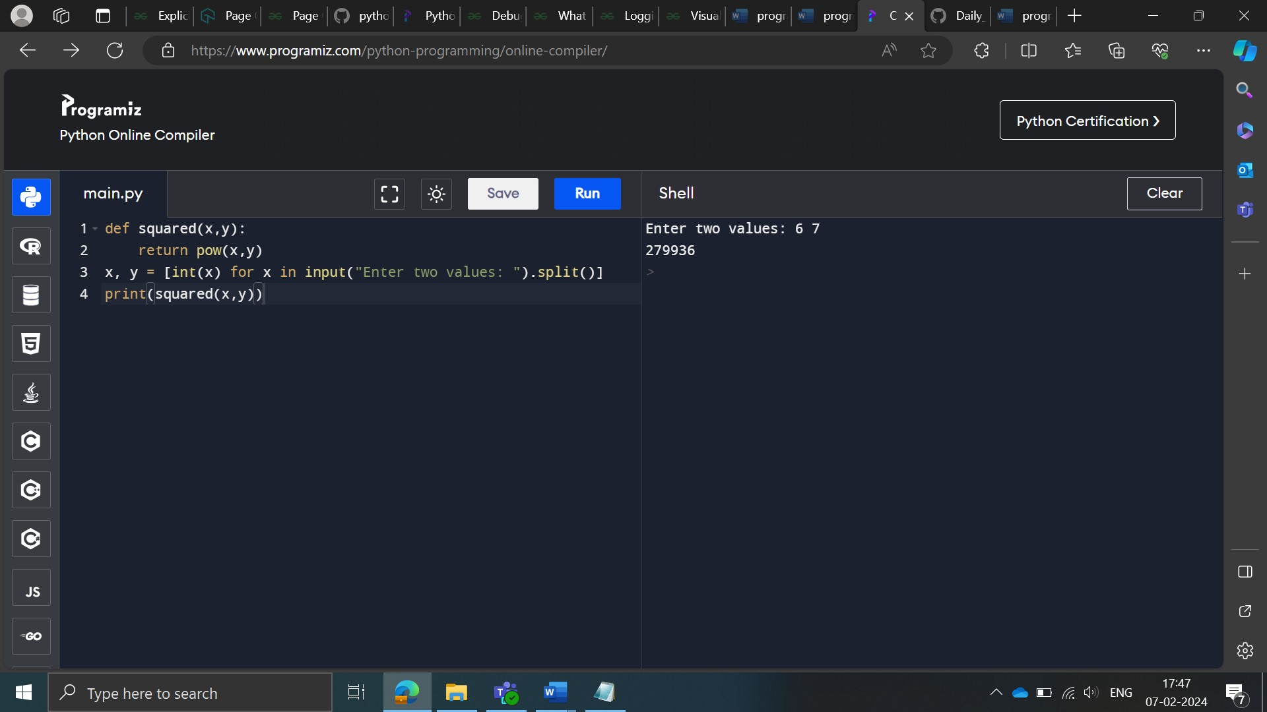

**Approach 3:**

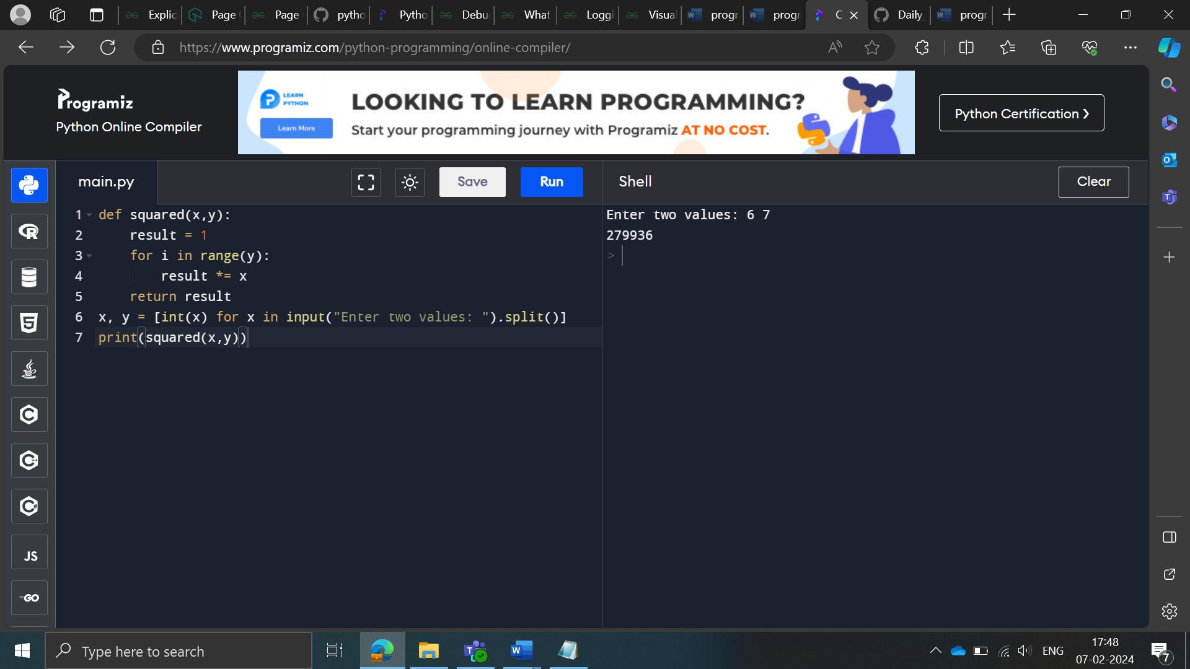

**Approach 4:**

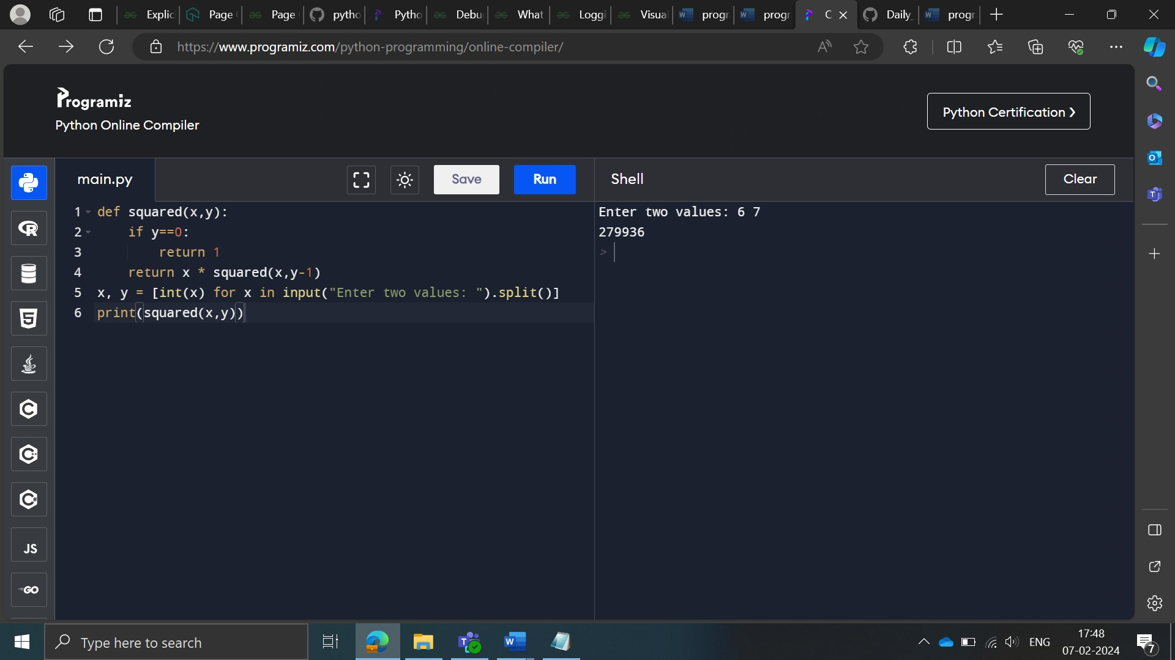

Description

You are given a list of string elements and asked to return a list which contains each element of the string in title case or in other words first character of the string would be in upper case and remaining all characters in lower case

Sample Input:

['VARMA', 'raj', 'Gupta', 'SaNdeeP']

Sample Output

['Varma', 'Raj', 'Gupta', 'Sandeep']

**Approach 1:**

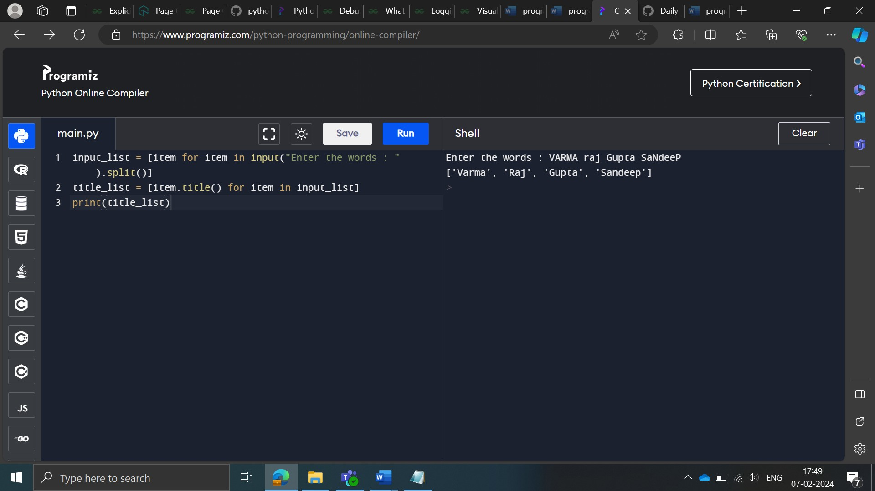

**Approach 2:**

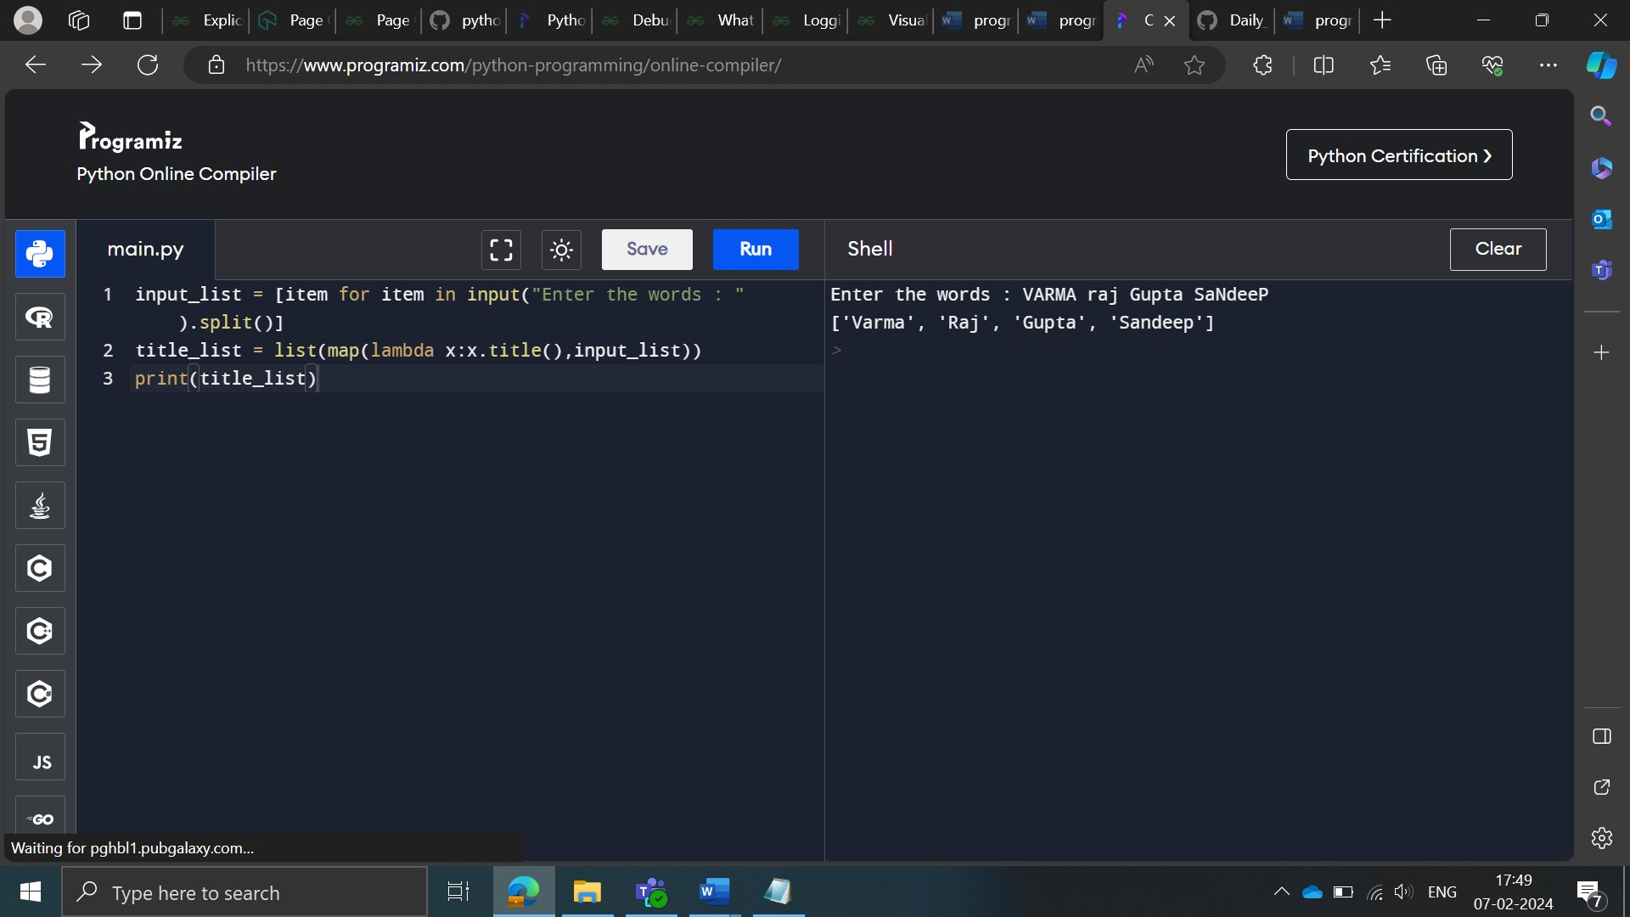

List Comprehensions

Description

Extract the words that start with a vowel from a list input_list= [wood, old, apple, big, item, euphoria] using list comprehensions.

Sample Input:

['wood','old','apple','big','item','euphoria']

Sample Output:

﻿['old', 'apple', 'item', 'euphoria']

**Approach 1:**

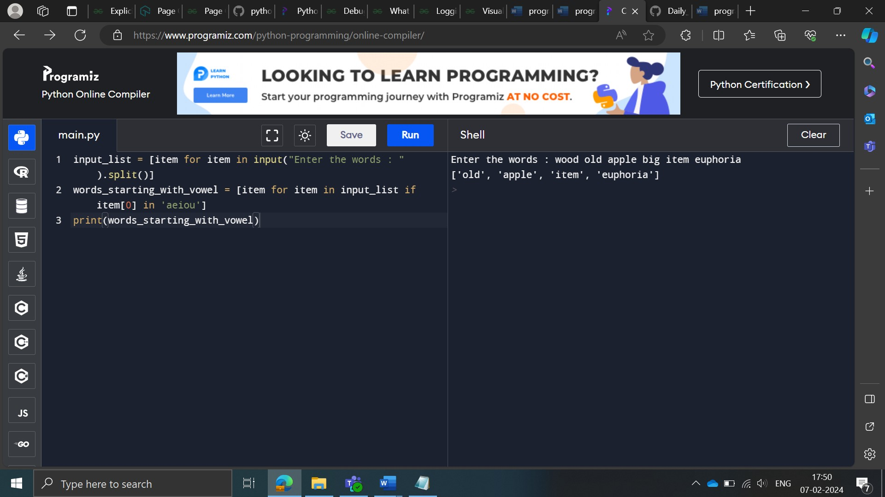

**Approach 2:**

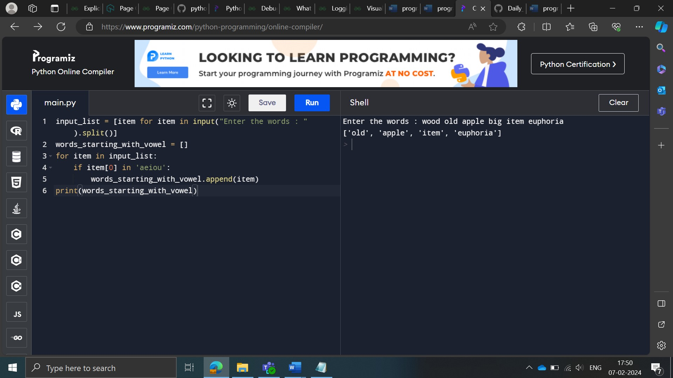

**Approach 3:**

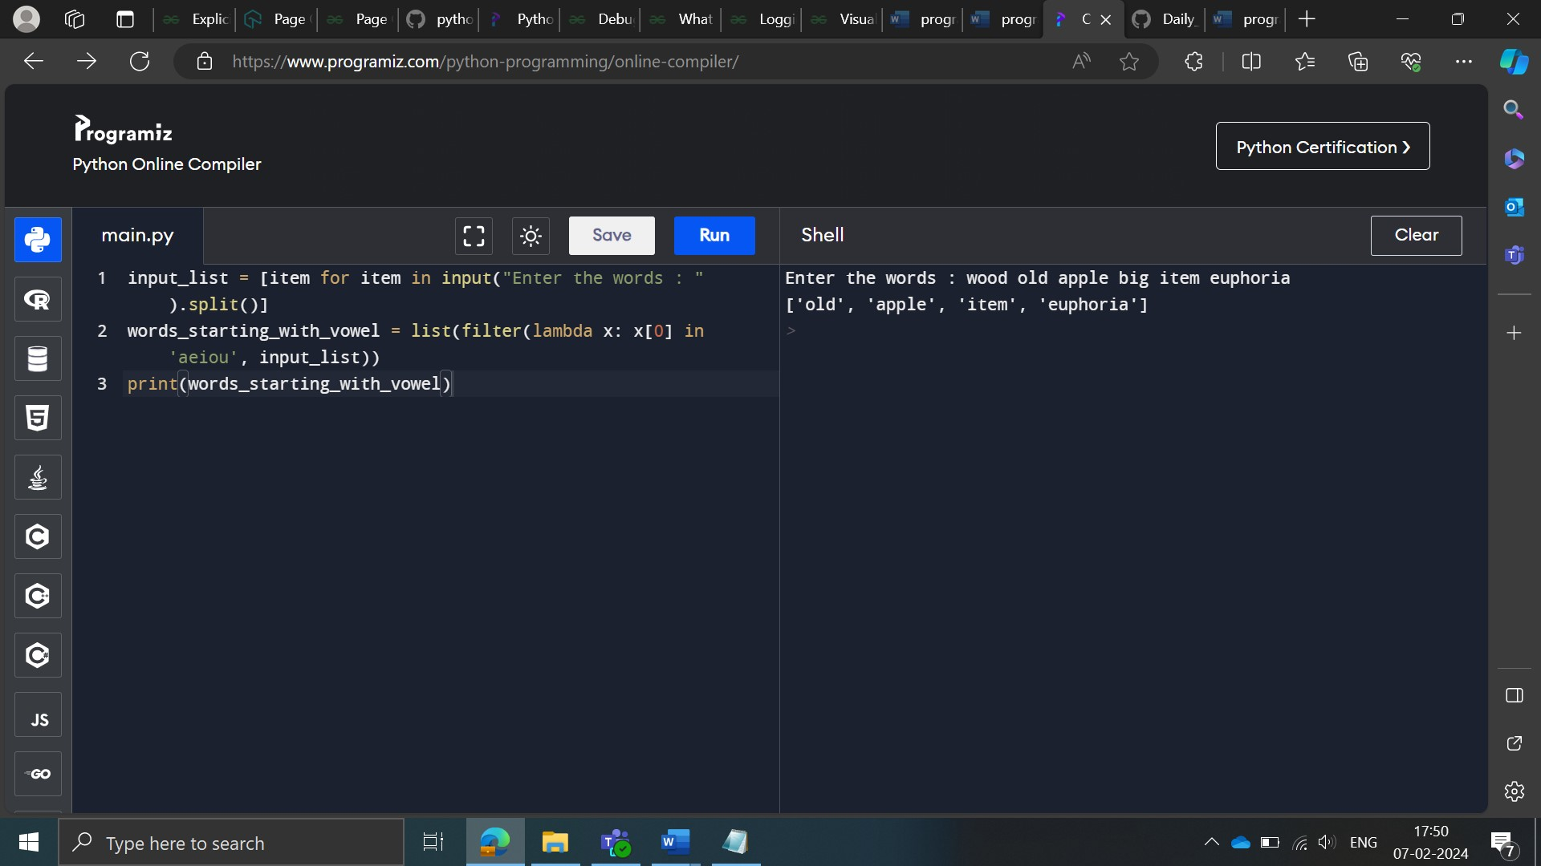

Dictionary

Description

Write code to fetch the profession of the employee with Employee id - 104 from an employee input given in the form of a dictionary where key represent employ id and values represent the name, age, and profession (in the same order).

**Sample input:**

Employee_data = { 101:['Shiva', 24, 'Content Strategist'] ,102:['Udit',25,'Content Strategist'], 103:['Sonam', 28,'Sr Manager'], 104:['Ansari',29,'Product Lead' ],105:['Huzefa',32,'Project Manager' ]}

**Sample output:**

'Product Lead'

**Approach 1:**

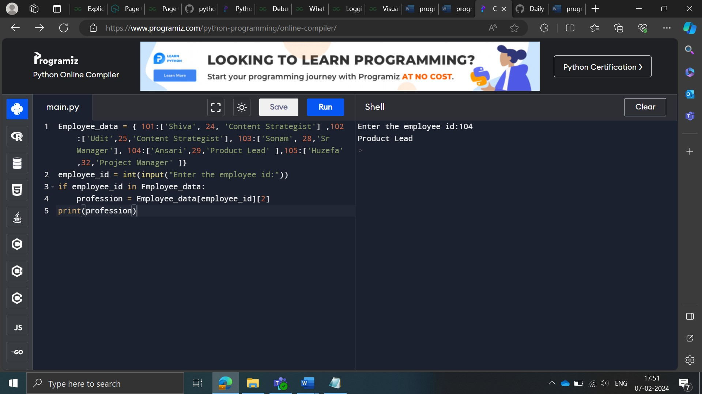

**Approach 2:**

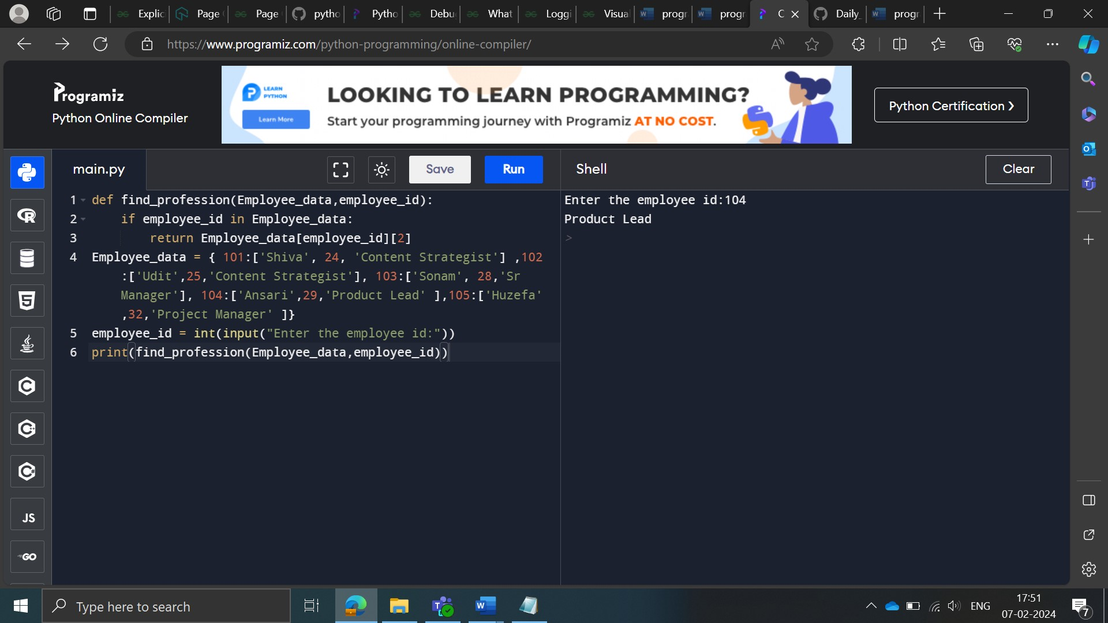

Dict_Error

Description

From a Dictionary input_dict={'Name': 'Monty', 'Profession': 'Singer' }, get the value of a key ‘Label’ which is not a part of the dictionary, in such a way that Python doesn't hit an error. If the key does not exist in the dictionary, Python should return 'NA'.

Sample Input:

{'Name': 'Monty', 'Profession': 'Singer' }

Sample Output:

NA

**Approach 1:**

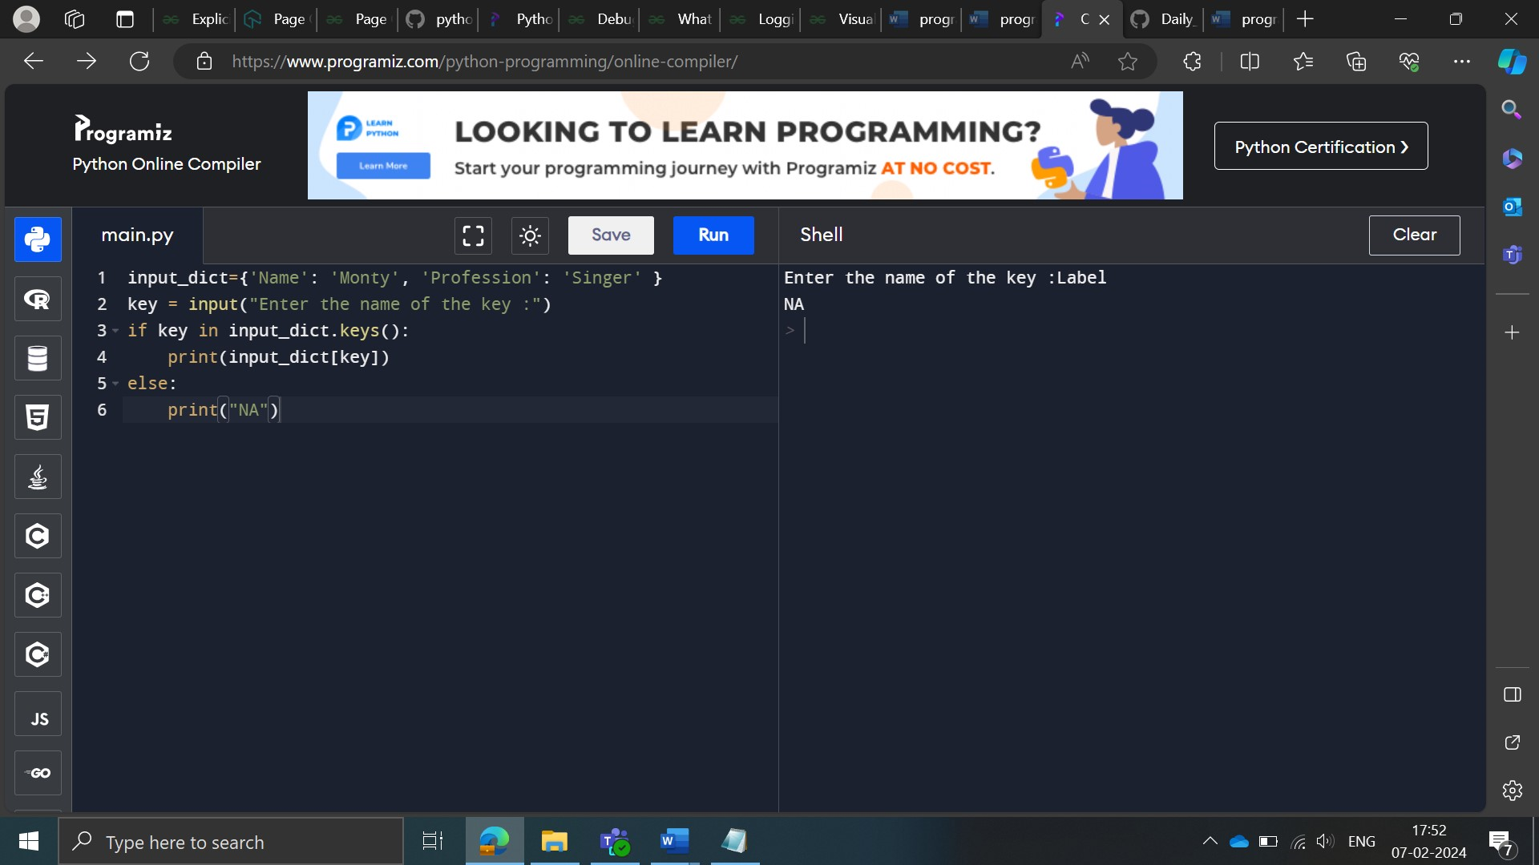

**Approach 2:**

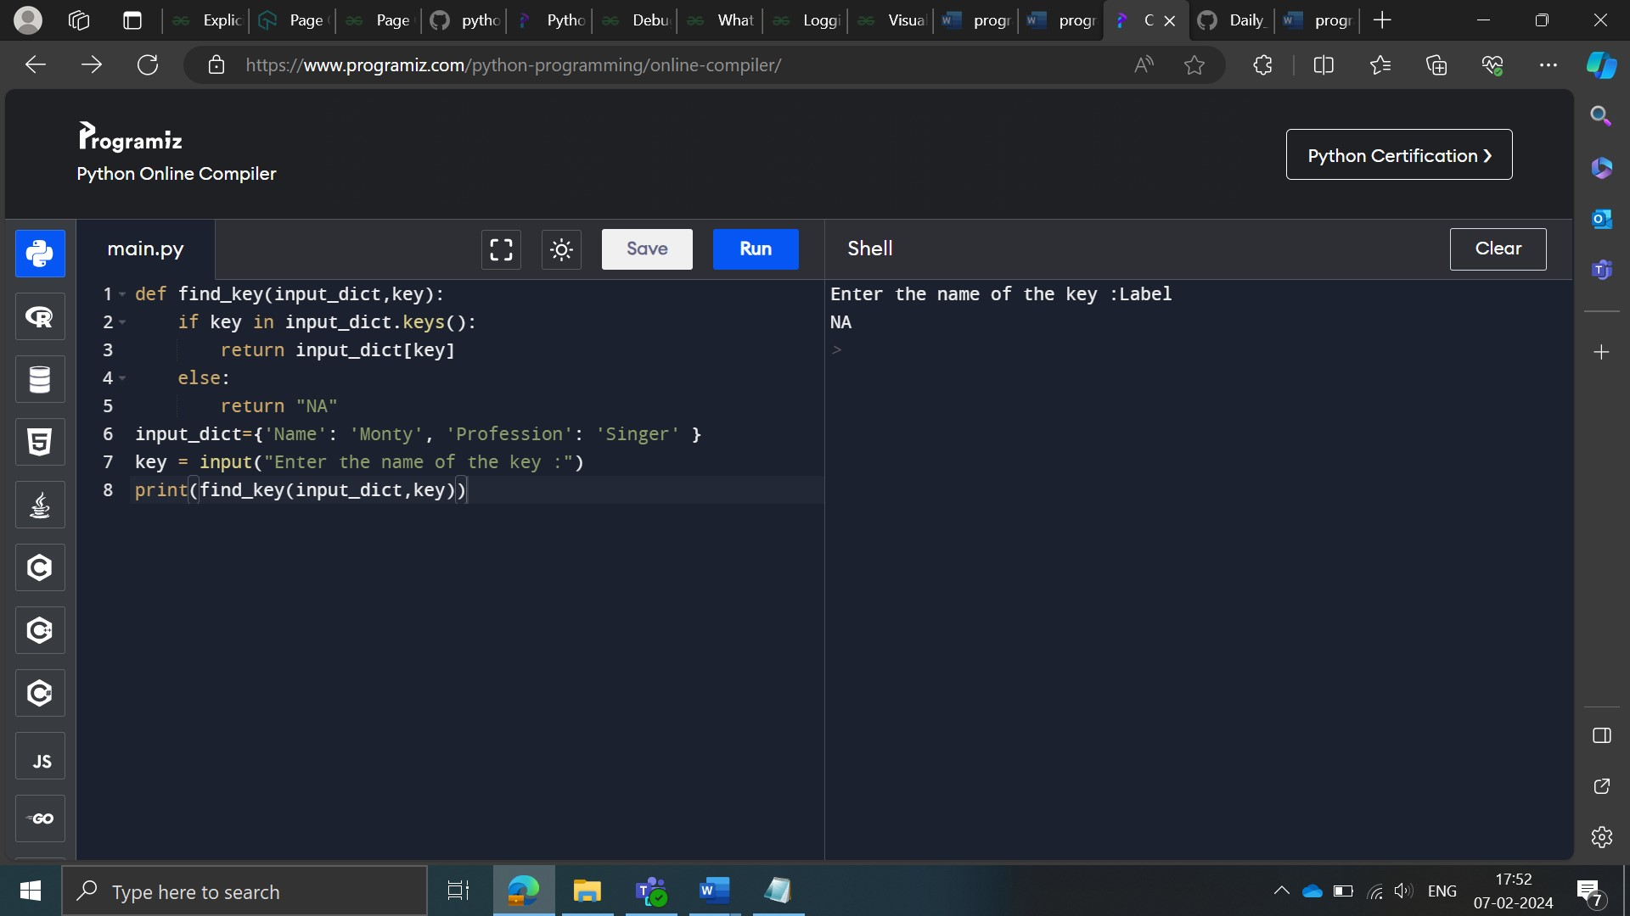

List of Values in a Dictionary.

Description

Create a SORTED list of all values from the dictionary input_dict = {'Jack Dorsey' : 'Twitter' , 'Tim Cook' : 'Apple','Jeff Bezos' : 'Amazon' ,'Mukesh Ambani' : 'RJIO'}

Sample Input:

{'Jack Dorsey': 'Twitter', 'Tim Cook': 'Apple', 'Jeff Bezos': 'Amazon', 'Mukesh Ambani': 'RJIO'}

Sample Output:

﻿['Amazon', 'Apple', 'RJIO', 'Twitter']

**Approach 1:**

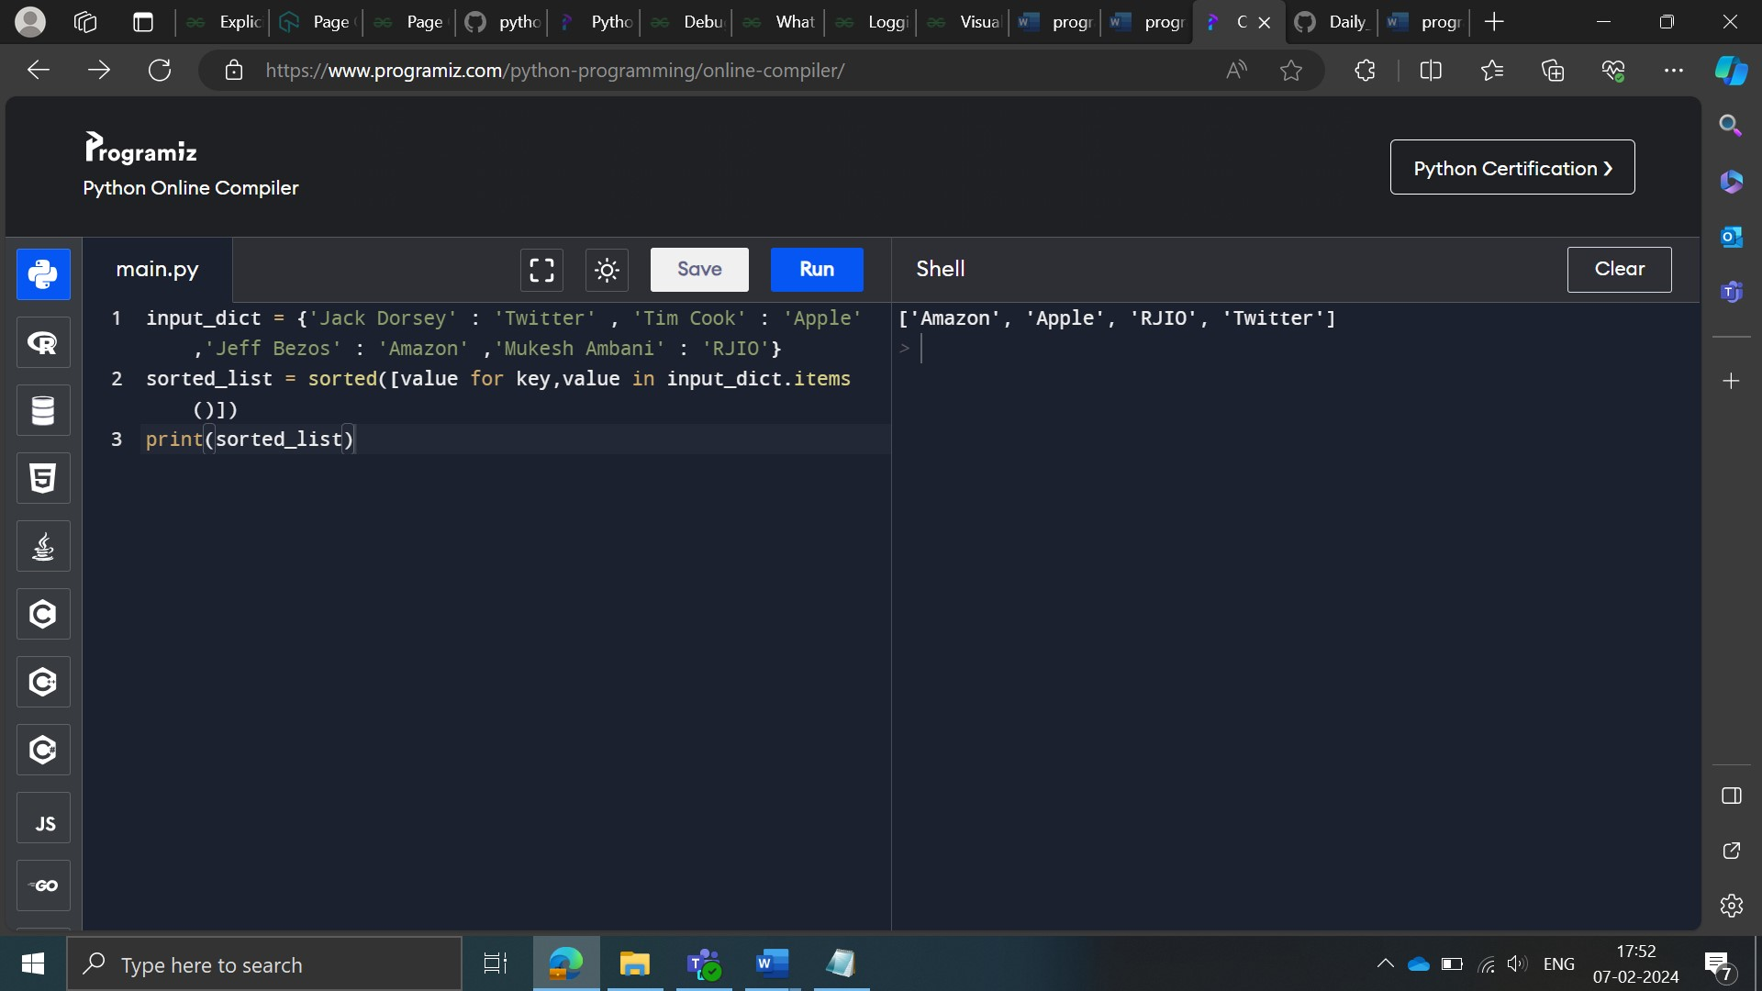

**Approach 2:**

